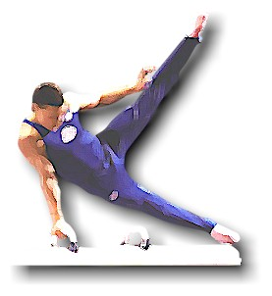 E17 GYMNASTICS CLUB 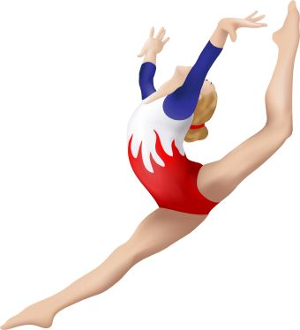
Ethos 1 – the Club will operate in an open culture based on transparency and trust between management, coaches, volunteers, members, and gymnasts.
How:
- The management, coaching and administration of the Club is undertaken in a manner which ensures delivery of the above aims and ensures that the rights of the coaches and gymnasts are respected by all in the Club, as defined by the English Sports Council.
- Membership of the Club is open to anyone interested in the sport regardless of sex, age, disability, ethnicity, nationality, sexual orientation, religion or other beliefs. Places will be offered on a fair basis from a waiting list
- Club fees will be kept at levels that are fair to ensure that the cost of membership does not pose a significant obstacle to people participating in the sport.

E17 GYMNASTICS CLUB
Ethos 2 – Gymnast Training Approach: We train gymnasts in a safe manner, using positive encouragement and praise and whilst seeking to develop life skills.
How:
- All coaches are required to coach in a safe manner and comply with all policies and procedures and health and Safety and accident reporting requirements
- A member of the Coaching Management Team must be in attendance for every session
- The Coaching Management Team and Executives must lead by example and instil a positive coaching style through the Club
- All coaches are empowered to challenge examples of poor coaching technique or behaviour, in a spirit of openness and honesty
- Group sizes will be limited to a maximum of 12 gymnasts per coach and 10 gymnasts per coach in the squad
- Each group coach must have a formal BG qualification
- A Club Competition will be run every year and with all Gymnasts encouraged to compete.

E17 GYMNASTICS CLUB
Ethos 3 - All our gymnasts and groups are treated with equal importance and supported to achieve their full potential within the sport according to their ability and ambition.
How:
- A named member of the senior coaching team is responsible for each group and for ensuring the development of each gymnast within that group.
- The coaching sessions for recreational groups will be organised to ensure a ratio of a minimum of 1 x 2 hour space for each 4 x 1 hour spaces
- The Junior Coaching group will be available for gymnasts wishing to become coaches.
- The structure of the coaching groups will be reviewed yearly, as a minimum, to ensure it is appropriate for the cohort of gymnasts within the Club.
Levels:
There are to be five levels of gymnast training:
- Working towards BAGA Badges - for 1 hour recreation
- Working towards Floor and Vault Competitions - 2 hour recreational
- Working towards Tumbling Competitions - Club Squad
- Working towards Formal Tumbling Competitions - Regional Squad
- Working towards national competitions – Elite Group
E17 GYMNASTICS CLUB
Ethos 4 – To provide an opportunity for as many children as possible to do Gymnastics
How
- The Waiting List will be kept to a minimum, within the capacity of the Club, with action taken to address if it over 50
Ethos 5 – The Club will be run to ensure its long term financial sustainability and in accordance to the standards set out by British Gymnastics and HRMC rules for a Community Amateur Sports Club Status (CASC)
How
- The Club is legal constituted, organised and managed to comply with CASC
- The Club will comply with GymMark standards for all gymnasts and coaches, including Development and Assessment Plans, Achievement Records.
- The Coaching Management Team will operate within the salary budget and training budget set by the Club Executive.

